Inspiring All to Excellence |  |  | 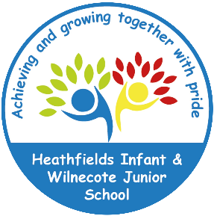

Heathfields Infant & Wilnecote Junior Academy

PSHE Policy

(Personal, Social, Health and Economic Education)

Document Control

Document Title | PSHE Policy
Effective Date |  | 22nd October 2022
Review Date | 22nd October 2024
Policy Owner | Lauren Paskin
Policy Approver

Version Control

Version | Date | Amended by | Comments
1 | 13/2/21 | Lauren Paskin
2 | 22/10/22 | Lauren Paskin | First aid and diversity

Section | Changes Made
Curriculum Organisation | Inclusion of first aid and diversity

Rationale
At the Heathfields Infant and Wilnecote Junior Academy, we are committed to the development of children’s social, emotional skills, children’s self-esteem, their health, and well-being. We are committed to developing the children’s responsibilities towards themselves, others in school, the local and global community.

This policy has been updated to reflect the development of the PSHE and Citizenship at our Academy based on the changes to the National Curriculum and the introduction of statutory RSHE in primary schools from September 2020. All schools are required to teach the majority of PSHE education from September 2020. This includes Relationships Education at key stages 1 and 2, Relationships and Sex Education (RSE) at key stages 3 and 4, and Health Education in both primary and secondary phases. Personal, Social and Health Education (PSHE) and citizenship enables children to become healthy, independent, and responsible members of society. It teaches children to reflect on and clarify their own values and attitudes and explore the complex and sometimes conflicting range of values and attitudes they encounter now and in the future. We encourage our pupils to play a positive role in contributing to the life of the school and the wider community. It equips them with knowledge and practical skills to live healthy, safe, fulfilled, and responsible lives. In doing so, we help develop their sense of self-worth. We teach them how society is organised and governed. We ensure that they experience the process of democracy in school through the election and membership opportunities provided through our academy’s School and Eco Council Program.

The issues that PSHE covers are central to children and young people’s well-being: nutrition and physical activity; drugs, alcohol, and tobacco; sex and relationships; emotional health and well-being; safety (including e-safety); careers; work-related learning and personal finance.

PSHE can be enhanced by a supportive school ethos, where all are valued and encouraged, positive relationships are seen as important and there is a safe and secure school environment that is conducive to learning.

Through PSHE, we will support children in their ability to:
- Have a sense of purpose
- Develop self-confidence and self-responsibility to themselves and others
- Make and act on informed decisions
- Communicate effectively
- Work with others including learn to respect the similarities and differences between people
- Be an active partner in their own learning
- Respond to challenge
- Be active citizens within the local community
- Become healthy and fulfilled individuals
- Develop a safe and healthy lifestyle
- Develop the ability to form good relationships
- Have opportunities to consider issues which may affect their own lives and the lives of others
- Provide children with the strategies and tools needed to understand and manage the range of their emotions
- To develop financial capability skills for future economic well-being.
- Prepare to play an active role as citizens by contributing to the life of the class, the school, the family, and the wider community

Curriculum organisation
Since September 2018, Wilnecote Junior Academy has adopted the Jigsaw PSHE scheme of work through which to teach children the above skills. Heathfields Infant School adopted the scheme in 2019. This scheme continuously develops in accordance with the ever-changing world that we live in. As such, in line with the updates to the National Curriculum in 2020 for PSHE, the Jigsaw Curriculum was updated to ensure that it meets the statutory guidance imposed by the Department for Education.

Term | Puzzle name | Content
Autumn 1: | Being Me in My World | Includes understanding their place in class, school, and global community as well as devising class learning charters
Autumn 2: | Celebrating Difference | Includes anti bully (cyber and homophobic bullying included) and diversity work
Spring 1: | Dreams and Goals | Includes goal setting, aspirations, working together to design and organise fund raising events
Spring 2: | Healthy Me | Includes drugs and alcohol education, self-esteem, and confidence as well as healthy lifestyle choices
Summer 1: | Relationships | Includes understanding friendships, family and other relationships, conflict resolution and communication skills
Summer 2: | Changing Me | Includes sex and relationships education in the context of looking at change

Jigsaw is a whole school programme that is progressive across year groups. All year groups will work on the same puzzle at the same time. Each puzzle consists of 6 pieces (lessons) which work towards a product.

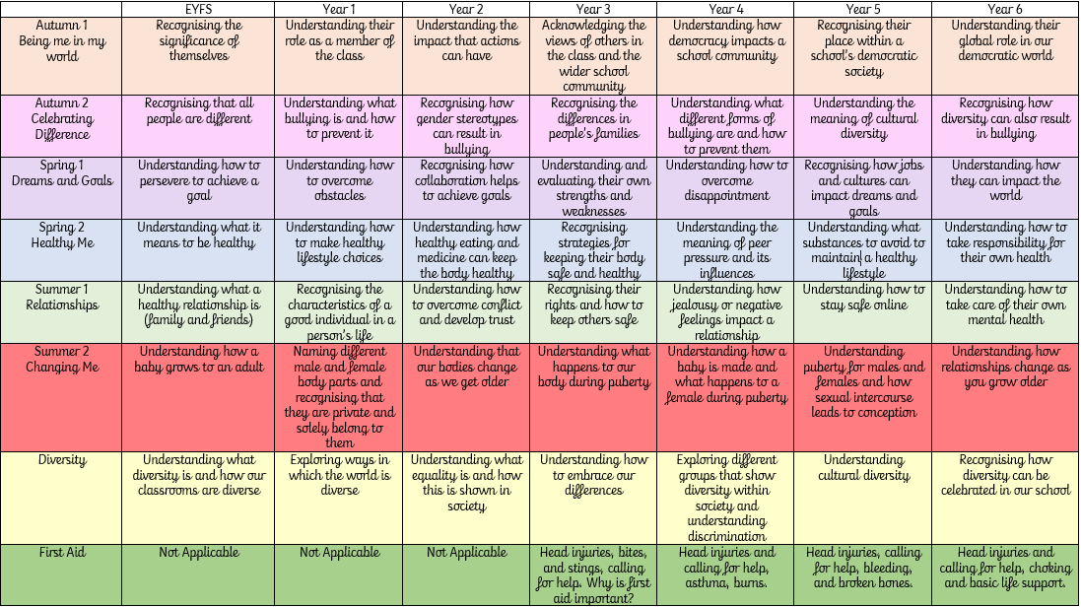
As an academy, we also recognise the need for the continuous development of our curriculum to coincide with our rapidly changing and evolving world. Therefore, we also aim to support the social and moral and development of our children through the teaching of:
- Diversity
- First Aid
- Safety Education
Through Safety Education, we provide the children in our school with a wide range of opportunities, using both internal and external providers to enable them to recognise and understand how to stay safe in many different situations that they may face as a developing member of society.

Teaching and Learning
We use a range of teaching and learning styles with an emphasis on active learning by including the children in discussions, investigations, and problem-solving activities. PSHE is provided in a variety of ways, to reflect the age of the pupils and ensure a whole school approach to the subject:
• There will be a weekly lesson; to develop themes and share ideas
• Opportunities will be found within other curriculum areas e.g., links with drama and role-play, debate, and discussion in English, working together in pairs or small groups, improving health in PE, environmental, SRE health and drug issues in science and beliefs, values, and practices in RE, E-Safety in ICT.
• Activities will be provided for individuals, groups and classes that engage and challenge thought processes and existing schemas
• At playtimes and lunchtimes opportunities exist for playing co-operatively using play equipment.
• In the Foundation Stage of the national curriculum PSHE is related to the objectives set out in the Early Learning Goals matching the aim of developing a child’s Personal, Emotional and Social Development and Understanding of the World.
• Much of the curriculum is delivered through oral and practical activities.
• Where appropriate pupils will record or investigate their work using a variety of mediums including books, internet, specific adults e.g., medical agencies, police service, fire service etc. This encourages children to develop their learning, enquiry skills and assists in equipping them for adult life.

PSHE days/events
Staff should be encouraged to use National and International celebration days (e.g. Internet Safety Day, Red Nose Day) to support PSHE where they can. School will also work with outside agencies to support learning outside of the classroom where it is appropriate and relevant to do so (e.g. Bikeability). The academy’s Twitter and Instagram accounts will be used regularly to update the community about the learning taking place in school surrounding PSHE in addition to updates to year group pages on the school’s website.

Relationship and Sex Education (RSE)
Effective relationship and sex education is essential if children and young people are to make responsible and well-informed decisions about their lives. It should not be delivered in isolation. It should be firmly rooted within the PSHE education across the school.

See Appendix 1 for how RSE is covered using Jigsaw PSHE in KS2.

Withdrawal from RSE lessons
Parents/Carers must be informed prior to the delivery of RSE lessons that this is going to take place through a letter either from the PSHE Leader or the Year Group Lead as appropriate (See Appendix 2 for a copy of this letter). Within this letter, Parents should be offered the opportunity to view any resources or lesson materials that their children will be exposed to throughout their RSE education to provide them with the opportunity to discuss this with their child, should they wish to, prior to the lessons in school due to the subject’s sensitive nature. Parents/Carers have the right to withdraw their children from RSE lessons within Jigsaw PSHE. Parents do not have to give reason for withdrawing their children but will be made aware of the implications of removing children. Once a child has been withdrawn, they cannot take part in RSE lessons until the request to withdrawal has been removed. Parents/Carers must be made aware that aspects of ‘sex education’ are statutory within National Curriculum Science. The focus in these lessons is on the biological aspects.

Note: RSE guidelines and requirements are subject to change. This policy will be updated when required to do so.

Assessment
The Department for Education (DfE) states in the statutory guidance for Relationships, Sex and Health education that “schools should have the same high expectations of the quality of pupils’ work in these subjects as for other curriculum areas”. Personal attributes, so central to PSHE education, are arguably the hardest aspects of learning to assess. It is difficult for teachers to accurately assess a pupil’s self-confidence or sense of their own identity and values. However, pupils themselves will be able to judge, for instance, whether they feel more confident, or have a firmer sense of their own beliefs and opinions than they did before a particular series of lessons. Therefore, personal reflection in PSHE education lessons is essential, so ensuring pupils have time and space within the lessons to reflect on this, either privately or through discussion, is a vital part of the Jigsaw curriculum which is followed by our academies. Learning in PSHE is not formally assessed, therefore a combination of peer and self-assessment following reflection in each lesson is vital in under to ascertain a child’s understanding of the subject content taught.

Monitoring and Evaluation
There will be ongoing evaluation and monitoring of the Jigsaw programme and PSHE by the PSHE subject leader, the Curriculum Leader and Senior Leadership Team. This will consist of talking to children about their understanding and knowledge of PSHE and Staff may be observed and will have opportunity to talk about PSHE within their lessons to support the development of both staff and pupils within this subject area. This will also enable the Curriculum Lead to assess any needs or wants within the school as well as any CPD opportunities required. Pupil conferencing will also be carried out to ascertain children’s understanding and engagement of the Jigsaw PSHE curriculum and amendments will be made as necessary.

British Values and UNICEF
Heathfields Infant and Wilnecote Junior Academy registered to obtain the Rights Respecting Schools Award (RRSA) Level 1. This award recognises achievement in putting the United Nations Convention on the Rights of the Child (CRC) at the heart of a school’s planning, policies, practice, and ethos. As a rights-respecting school we not only teach about children’s rights but also model rights and respect in all the relationships: between teachers/adults and learners, between adults and between learners.

This policy reflects contributions by the whole school community including learners, staff, parents, carers and governors as a Rights Respecting School and should therefore be promoted by all community members.

We take every opportunity to promote the fundamental British values of:
- Democracy
- The rule of law
- Individual liberty
- Mutual respect and tolerance of those with different faiths and beliefs
In actively promoting British Values, we also focus on and can show, how our work with students is effective in embedding fundamental British values. Actively promoting also means challenging students, staff, parents, or carers that may express opinions contrary to fundamental British Values, including extremist views.

Growth Mindset
A key concept which shapes the ethos of our school is growth mindsets based on the work of Carol Dweck. Rather than simply praising success we praise effort and persistence. Children are encouraged to approach all aspects of school life with a positive mentality and resilience, allowing them to achieve all that they are capable of. Our behavior policy falls in line with this approach as children are supported to regulate their emotions as they move through our ‘behavior islands’.

We have a three-tier behavior management system:
- When the children are showing a positive attitude towards their learning or play then they are on the pink island.
- If the child is not able to show a positive attitude towards their learning or play then they will be reminded and asked to regulate and change their behavior, if they are not able to do this they will move to the green island.
- If they manage their behavior through regulation they are praised and moved to the purple island to celebrate the change in attitude.

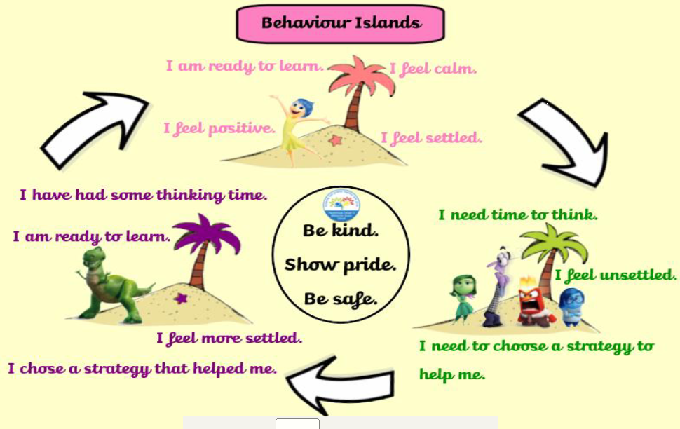
As with other behavior management systems, some behavior will be deemed as unacceptable.
All classes have a ‘regulation station’ which children can access freely to regulate their emotions when moving through the behaviour islands.

Equal Opportunities
At our Academy, we endeavour to ensure that irrespective of race, ethnicity, gender, class or disability, all children receive the entitlement to relevant experience which will enable them to access learning. Thus, when planning the curriculum in PSHE the needs of every child must be considered. Where it is seen to be a priority and agreed by the PSHE leader, Curriculum Leader or Senior Leadership Team, staff training is organised.

Staff Professional Development
The PSHE lead is part of a network for PSHE leaders within the Fierte Multi Academy Trust to stay up to date with key developments and initiatives. Information gathered from this network, will shared either via email or through staff meetings to ensure that Class Teachers and the wider school are aware and fully up to date with the curriculum.

Specific Issues

Child Protection
All adults working with children have to be DBS checked and trained in Safer Working Practices. If any issues arise during a PSHE lesson they must be shared with the Head Teacher who is the Designated Safeguarding Lead for those that are considered ‘at risk’.

Confidentiality
Confidentiality is not guaranteed, and the boundaries of confidentiality are made clear to the children. If a pupil discloses information which is sensitive, not generally known, and which the pupil asks not to be passed on, the request is honoured unless this is unavoidable for teachers to fulfil their professional responsibilities in relation to Child Protection. It is the responsibility of every member of staff to know and abide by the school’s child protection procedures. If any member of staff has a concern about the safety of a pupil these must be recorded and passed on to the school’s Designated Safeguarding Lead(s).

Appendix 1

Year  group | Piece Number and Name | Learning intentions  ‘Pupils will be able to...’
3 | Piece 1  How babies grow | Understand that in animals and humans lots of changes happen between conception and growing up, and that usually it is the female who has the baby.  Express how they feel when they see babies or baby animals.
 | Piece 2  Babies | Understand how babies grow and develop in the mother’s uterus and understand what a baby needs to live and grow.  Express how they might feel if they had a new baby in the family.
 | Piece 3  Outside body changes | Understand that boys’ and girls’ bodies need to change so that when they grow up their bodies can make babies.  Identify how boys’ and girls’ change on the outside during this growing up process.  Recognise how they feel about these changes happening and know how to cope with those feelings.
 | Piece 4  Inside body changes | Identify how boys’ and girls’ change on the inside during the growing up process and why these changes are necessary so that their bodies can make babies when they grow up.  Recognise how they feel about these changes and how tow to cope with those feelings.
 | Piece 5  Family Stereotypes | Start to recognise stereotypical ideas about parenting and family roles.
4 | Piece 1  Unique Me | Understand that personal characteristics come from birth parents, and this happens because people are made from the joining of the sperm and the egg.
 | Piece 2  Having a baby | Correctly label the internal and external parts of a male and female body that are necessary for making a baby.  Understand that having a baby is a personal choice and express how they feel about having children when they are an adult.
 | Piece 3  Girls and Puberty | Describe how a girl’s body changes for her to be able to have babies when she is an adult, and that menstruation is a natural part of this.  Know that they have strategies to help them cope with physical and emotion changes experienced during puberty.
5 | Piece 1  Self and Body Image | Learn to be aware of self-image and how an individual’s body image can fit into that.
 | Piece 2  Puberty for girls | Explain how a girl’s body changes during puberty and understand the importance of looking after themselves physically and emotionally.  Understand that puberty is a natural process that happens to everybody and that it will be OK.
 | Piece 3  Puberty for boys and girls | Describe how boys’ and girls’ bodies change during puberty.  Express how they feel about the changes during puberty.
 | Piece 4  Conception | Understand that sexual intercourse can lead to conception and that is how babies are usually made.  Understand that sometimes people need IVF to help them have a baby.  Appreciate how amazing it is that human bodies can reproduce in these ways.
 | Piece 5  Looking Ahead 1 | Identify what to look forward to about becoming a teenager and understand that this brings growing responsibilities. (Age of consent)
6 | Piece 2  Puberty | Explain how girls’ and boys’ bodies change during puberty and understand the importance of looking after themselves physically and emotionally.  Express how they feel about the changes during puberty.
 | Piece 3  Babies: Conception to Birth | Describe how a baby develops from conception through the nine months of pregnancy, and how it is born.  Recognise how they feel when they reflect on the development and birth of a baby.
 | Piece 4  Boyfriends and Girlfriends | Understand how being physically attracted to someone changes the nature of the relationship.  Express how they feel about growing independence of being a teenager and are confident that they can cope with this.

Appendix 2
Dear Parent/Carer,

Next half term, children in Years … will receive information from their teachers relating to Relationships and Sex as a result of the introduction of compulsory Relationships and Sex Education for all children in Key Stage 2 by the Department for Education from September 2020.

These sessions are part of our wider PSHE (Personal, Social, Health and Economic education) and RSE (Relationships and Sex Education) policies with elements of this also being covered within the National Curriculum for Science.

In Years 3 and 4, both boys and girls will be covering the following aspects:
- How our bodies change physically as we grow up, including an introduction to menstruation in Year 4.
- What the ‘ingredients’ are for making a baby.

All the resources we use are part of the Jigsaw PSHE materials we are using as a school.

If you would like to see the resources before we share the information during lessons, please contact Miss Paskin through the year 3 email (year3@wilnecote.fierte.org) by ……. and we can share these with you.

Many thanks for your support of our school.

Yours sincerely,

Mrs Glover Miss Paskin
(Head of School) (Year 3 Teacher)

