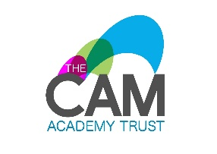

Wilnecote Junior Academy: Modern Foreign Languages Policy

Purpose of Study

Learning a foreign language is a liberation from insularity and provides an essential opening to other cultures. A high-quality languages education should foster pupils’ curiosity and deepen their understanding of the world. The teaching should enable pupils to express their ideas and thoughts in another language and to understand and respond to its speakers, both in speech and in writing. It should also provide opportunities for them to communicate for practical purposes, learn new ways of thinking and read great literature in the original language.

The learning of a foreign language can provide a valuable educational, social and cultural experience for pupils – providing them with:
- Opportunities to communicate for practical purposes in the wider world.
- A foundation for further learning of languages beyond KS2, equipping pupils to study and work in other countries.
- An essential opening to other cultures and a widening of experiences and aspiration.
- A new perspective on the world, encouraging them to understand their own cultures and those of others.
Key Stages 2
The statutory phase of language learning comprises the seven years of KS2 and KS3. CAT academies are committed to fulfil the aims and deliver the learning outcomes of the National Curriculum Languages programmes of study for both key stages. In brief, these are to ensure that all pupils at KS2:
- develop their interest in the language(s) and culture(s) of other countries.
- develop their practical communication skills by understanding and responding to both spoken and written language.
- make substantial progress in one language (although they may have additional opportunities to learn more than one language).
- understand basic grammar appropriate to the language studied.
- have a solid foundation for further language study at KS3, where possible in the same language that will be studied at KS3.
Curriculum intent
At Wilnecote Junior Academy children are given the opportunity to develop their French language skills as well as learn about French culture and traditions. Children will learn to express their thoughts and ideas in French and be able to respond through speaking and listening and in reading and writing. We believe that foreign language learning is full of rich opportunities to develop pupil’s spiritual, moral and cultural experiences

Essential Knowledge

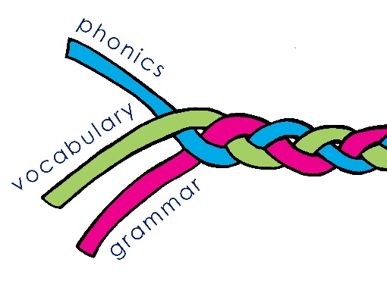
We teach three core strands of essential knowledge:
- Phonics – the key components of the sound-writing relationship
- Vocabulary – a set of the most frequently used words
- Grammar – the essential building blocks required to create simple sentences independently (including gender of nouns, singular and plural forms, adjectives (place and agreement), and the conjugation of key verbs)

Our French curriculum is designed to enable our children to:
- Develop linguistic and communicative competence
- Extend their knowledge of how language works
- Explore similarities and differences between [name of language], any heritage languages our children have, and English

The teaching of a foreign language to every child in KS2 is a statutory requirement, as set out in the National Curriculum Programmes of Study (2014).
In line with the NC PoS, our children learn to:
- Listen and show understanding by joining in and responding
- Link the sound, spelling and meaning of words
- Read aloud with accurate pronunciation
- Read and show understanding of phrases and simple texts
- Speak in sentences
- Describe people, places, things in speech and writing
- Ask and answer questions
- Express opinions
- Write phrases from memory
- Adapt phrases to create new sentences
- Use a dictionary

Our children also learn key cultural and country-specific knowledge. For example, by the end of KS2, our children:
- can name and locate on a map countries where French is spoken
- know the key geographical features of France including continent, surrounding seas and oceans, main mountains and rivers, capital city
- know the name and some detail about at least one festival or tradition from France
- know at least one typical food from France

Curriculum provision

Our KS2 children have a weekly French lesson of 40 minutes. Further opportunities to recycle key vocabulary (e.g. numbers) and develop children’s confidence are often built into classroom routines including greetings, providing instructions, stating lunch preferences, registration, rewards and praise on a more regular basis, even just for a few minutes in the school day e.g. when children are lining up.

A detailed scheme of work with audio-enabled resources for every lesson is provided in order to minimise unnecessary teacher workload. Teachers may, if they wish, adapt the resources to support active engagement and meet different learning styles for different cohorts of children.

Assessment
Children are continuously assessed on the knowledge they are taught in lessons. Periodically they complete achievement tests in phonics, vocabulary and grammar covering all modalities (i.e. listening, speaking, reading and writing), which assess the specific knowledge they have been taught. Their progress and attainment is categorised in the following way, using our school tracking system:
- Meeting expectations
A child has learnt and retained the majority of phonics, vocabulary and grammar knowledge taught this term
- Above expectations
A child has learnt and retained all of the phonics, vocabulary and grammar knowledge expected this term, and has shown additional capacity for extending his/her knowledge.
- Below expectations
A child has learnt and retained less phonics, vocabulary and grammar knowledge than expected this term

Equal Opportunities and SEN

All children irrespective of ability or special educational need, should be taught a foreign language. Every child has the statutory right to a broad and balanced curriculum.
A child with SEN should be actively encouraged to participate fully in MFL lessons with the necessary support and appropriate differentiation.

Teaching modern foreign languages is a vital way to directly address pupil perceptions and potential stereotypes. It allows us to actively promote positive attitudes and values towards cultural and or religious diversity and to directly tackle any form of cultural and negative stereotyping.

PREVENT Duty (April 2019)

Section 58. All publicly-funded schools in England are required by law to teach a broad and balanced curriculum which promotes the spiritual, moral, cultural, mental and physical development of pupils and prepares them for the opportunities, responsibilities and experiences of life. They must also promote community cohesion.

Role of the Subject Leader
The subject leader will:
- ensure staff are fully aware of statutory requirements and their associated responsibilities in terms of policy and practice
- support staff in terms of access to SOW and resources
- monitor the quality of teaching and learning
- draw upon advice, support and expertise where necessary and in order to improve provision
- liaise to organise training and support to develop teacher subject knowledge and expertise.

Policy Review
This policy will be reviewed when necessary and in the light of any changes or developments in terms of statutory requirements.

